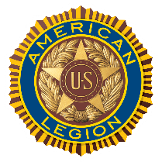
American Legion Orem Post 72
General Post Meeting Agenda
August 12, 2026 @ 1830-2000 hrs.
utlegionpost72.org

Call to Order: David Morris, First Vice Commander
Invocation: _____________________
Pledge of Allegiance: __________________
Preamble:
Moment of Silence for POW
Welcome to all post members, family, and guests
Presenter: Joshua Morrison, Boys State accomplishments, Angie Fisher, Car Show
Entertainment: Glory Thomas
Motion to Approve: July’s minutes, by________________2nd______________________
Release of Ott Dameron and Russ Rader form PEC, by___________2nd_________________
Approved of appointments of Bob Myers and Bill Johnson as members of the PEC, by____________
2nd_____________
Approve Financial Report, by____________________2nd_________________________

Reports:

Vice Commander, David Morris
- Membership Renewal Report
- Family Leadership Academy Veterans Event
- Recommend help fund event
- Encourage all to come and bring family

Vice Commander, Kelly Kirkpatrick
- Calendar & Events (found on Website & Emailed)
- Discuss issues and planning for Veteran’s Day Program

Finance/Webmaster, Hilton Campbell
- Venmo is active
- https://utlegionpost72.org – post service hours

Commander’s Comments: Rodney Gardner
- Website
- Called Upon to Serve, Lindon Days Honor Guard Socials and Dinners

Benediction:

